entity relationship diagram (ERD)

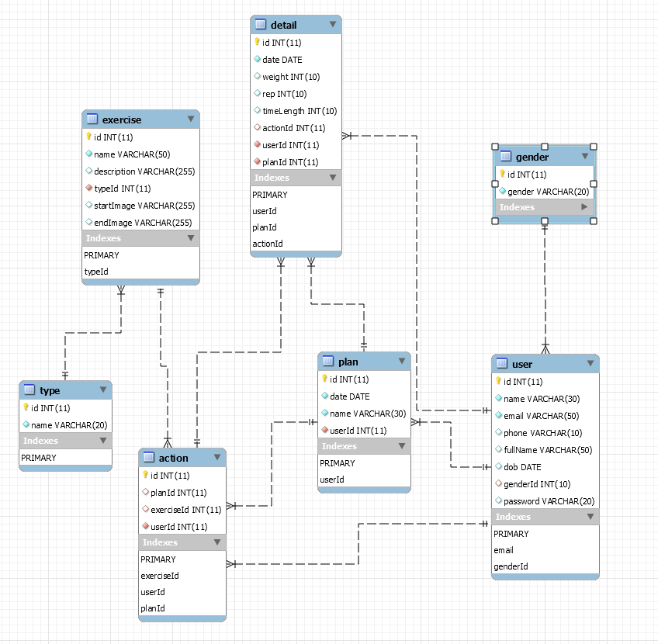

Figure : Entity Relationship Diagram (ERD) for IQWorkout app